
Maria Karla L. Gonzales
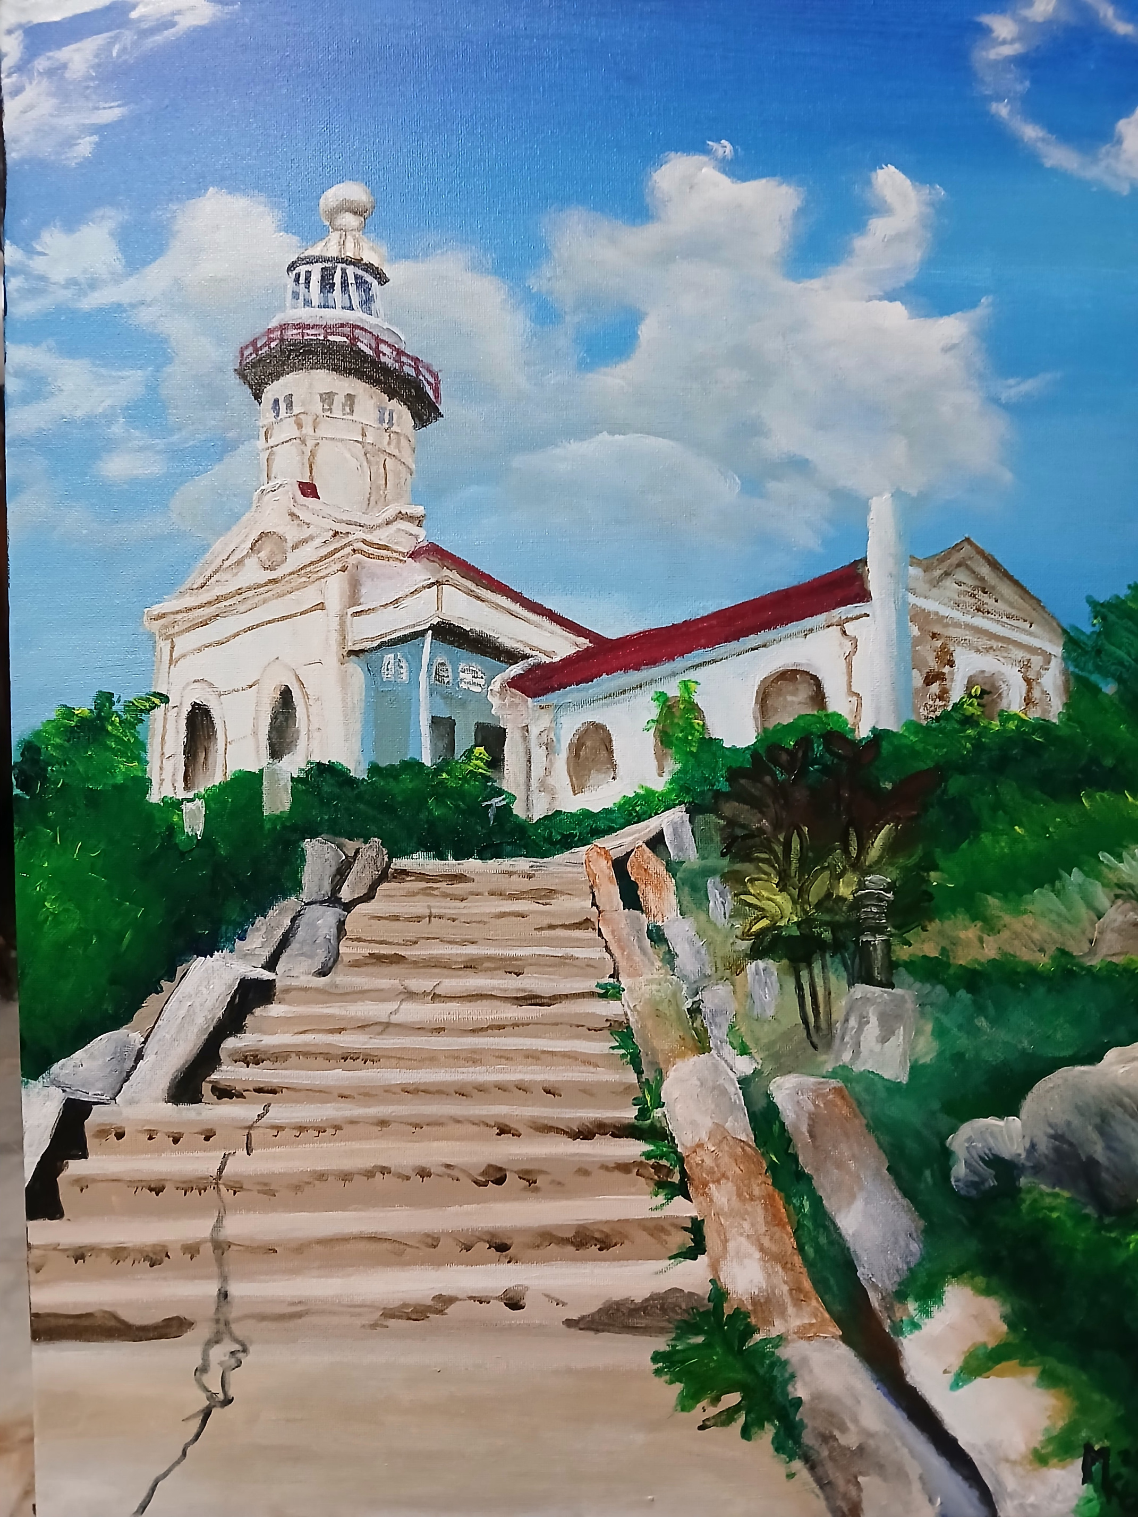
Title: Light tower Ilocos
Size: 18inches x 24inches
Medium: acrylic on canvas
This is a scenery of Cape Bojeador Lighthouse.

